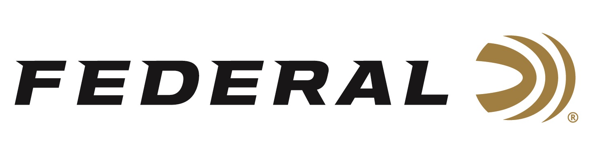

FOR IMMEDIATE RELEASE

Froelich Finishes First at Texas 3-Gun Championship

ANOKA, Minnesota – May 3, 2021 – Team Federal congratulates Josh Froelich on winning a title at the Texas 3-Gun Championship held at Reveille Peak Ranch near Burnet, Texas April 30 through May 2, 2021. Froelich was the 2X4 Division title winner over two-hundred and fifty competitors in the five-division event that featured ten natural terrain stages with a weekend filled with gusty winds and rainy conditions.

“Shooting well came down to who could manage the mental game amidst the weather and who could trust their gear and ammunition and just focus on the shooting,” stated Froelich. Relying on Syntech Action Pistol, Gold Medal Berger rifle and Gold Medal shotgun shells, the veteran shooter navigated the tricky footing in the Texas hill country to win this prestigious event.

“This was my 3rd win in a row in Texas and one of the more challenging matches in the country, so a win here lets me know things are tracking in the right direction at the beginning of the shooting season,” stated Froelich. The world class shooter will now focus his training regimen on the USPSA 2Gun PCC/Pistol Nationals in June. The event is scheduled for CMP Talladega Marksmanship Park in Talladega, Alabama June 5-6, 2021.

Federal ammunition can be found at dealers nationwide or purchased online direct. For more on Federal ammunition, visit www.federalpremium.com.

Press Release Contact: JJ Reich
Senior Manager – Press Relations
E-mail: VistaPressroom@VistaOutdoor.com

About Federal Ammunition
Federal, headquartered in Anoka, MN, is a brand of Vista Outdoor Inc., an outdoor sports and recreation company. From humble beginnings nestled among the lakes and woods of Minnesota, Federal Ammunition has evolved into one of the world's largest producers of sporting ammunition. Beginning in 1922, founding president, Charles L. Horn, paved the way for our success. Today, Federal carries on Horn's vision for quality products and service with the next generation of outdoorsmen and women. We maintain our position as experts in the science of ammunition production. Every day we manufacture products to enhance our customers' shooting experience while partnering with the conservation organizations that protect and support our outdoor heritage. We offer thousands of options in our Federal Premium and Federal® lines-it's what makes us the most complete ammunition company in the business and provides our customers with a choice no matter their pursuit.

